Array Function

1 Push

let myArr =[0,1,2,3,4,5,6,7,8,9]

/ myArr.push(6)

// console.log(myArr);

2 POP

let myArr =[0,1,2,3,4,5,6,7,8,9]

myArr.pop()

console.log(myarr)

3 Unshift

let myArr =[0,1,2,3,4,5,6,7,8,9]

myArr.unshift(90)

console.log(myarr)

4 Shift

let myArr =[0,1,2,3,4,5,6,7,8,9]

myArr.shift(90)

console.log(myarr)

5 Includes:

it will check the 7 is present in the array or not

let myArr =[0,1,2,3,4,5,6,7,8,9]

console.log(myArr.includes(7))

6 Index of

let text = "Hello world, welcome to the universe.";  
text.indexOf("e", 5);

Output:

Find "e", start at position 5:

14

Ex2

Find the first occurrence of "e":

let text = "Hello world, welcome to the universe.";  
text.indexOf("e");

Interview Question Important:

* Note: Javascript is an single threaded :
* Javascript Execution Context
* Two execution Context

1. Global Execution Context
2. Function /Functional Execution Context.
3. Optional…. Eval Execution Context in MongoDb

How javaScript Code Execute :

They run two phases:

1. Memory **Creation Phase –** variable y jo bhi declare kie hai unke space allocate hoti hai .
2. **Execution Phase** : +,-,* y sb eute hote hai .

Ex –

Let val1 =10

Let val2 = 5

Function addNum(Num1,Num2){

Let total =num1 + num2

Return total

}

Let result1 =addNum (val1 ,val2)

Let result2=addNum(10,2)

**How Above Code Execution:**

**Step1:** Global Execution jo bhi code run krne ho vo Global Execution s hote hai or isko sbse phele allocate kie jate **this** k andr.

**Step2 /Cycle 1:**  Memory Creation Phase: val1 ->undefined…. jo variable declare kie hai unhe lie jate hai or unke andr rhke jate hai undefined.

Val2🡪 undefined

addNum-> definition function k andr jo bhi hai vo definiation m chlegye.

Result1 -> undefined

Result2-> undefined

Step3/Cycle2 :Execution Phase

Val1 🡨 10

Val2🡨s5

Function ki definition hold krke rhkdi hai

New Variable environment  
 +

Execution Thread

Result1 = addnum🡪

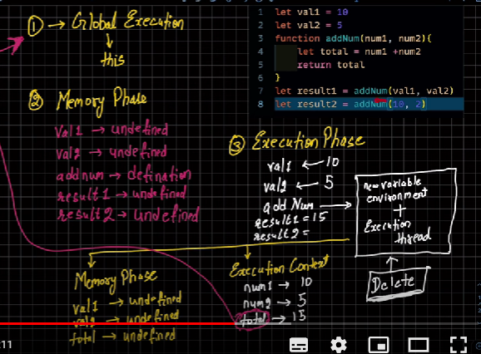

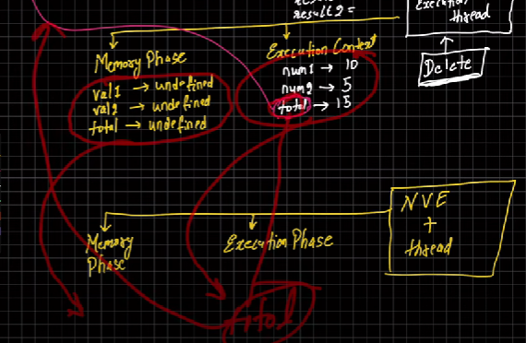

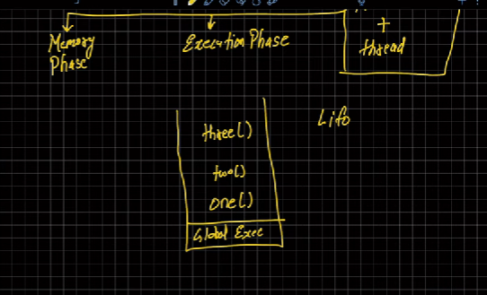

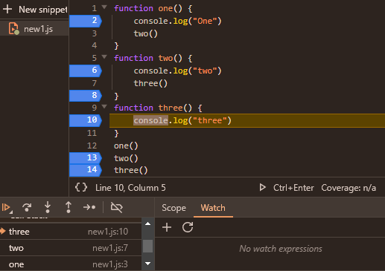

This box is called an sandbox

Jiti br y function call hote hai uti br y box create hote hai iske bolte hai **New Execution Context .**

Note : jiti br finction call hoge uti br box bnege jiti bar box bnege uti br **step:2 and step3 call hoge .**

**Global variable is define only one time.**

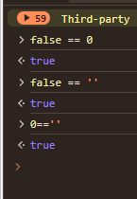

DOM Digram

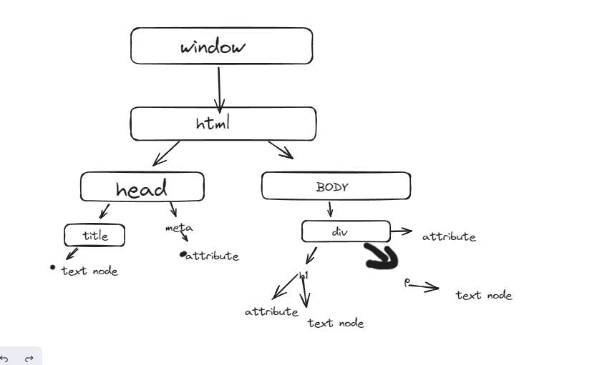

DOM

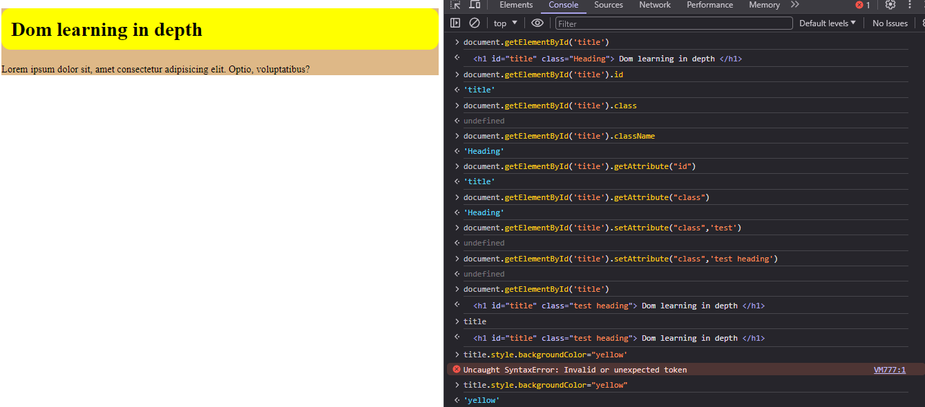

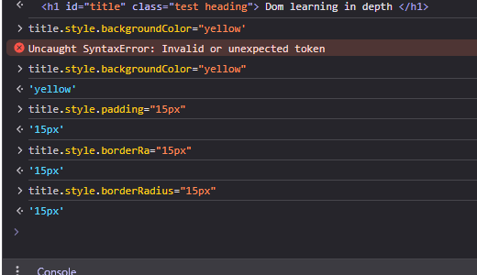

innerHTML and Textcontent

in innerhtml🡪 sirf jo code visible hai vhi show hoge

in textcontent🡪isme sare code display hoge

Ex- >

<!DOCTYPE html>

<html lang="en">

<head>

    <meta charset="UTF-8">

    <meta name="viewport" content="width=device-width, initial-scale=1.0">

    <title>DOM learning</title>

    <style>

        .bg-black{

            background-color: burlywood;

        }

    </style>

</head>

<body>

    <div class="bg-black">

        <h1 id="title" class="Heading"> Dom learning in depth  <span style="display: none;">New Text code</span></h1>

        <p>Lorem ipsum dolor sit, amet consectetur adipisicing elit. Optio, voluptatibus?</p>

    </div>

</body>

</html>

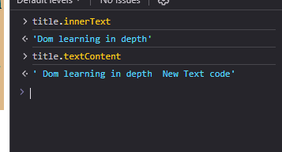

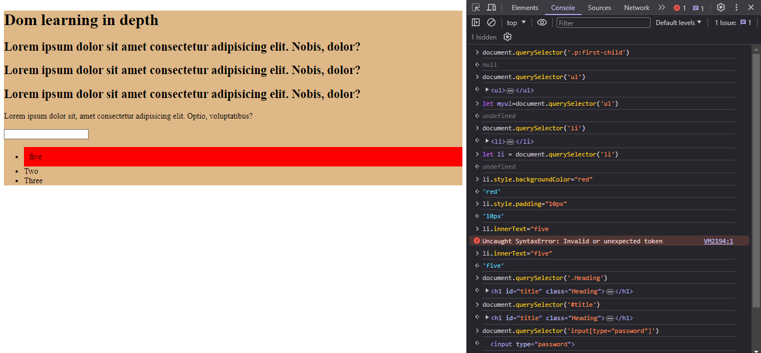

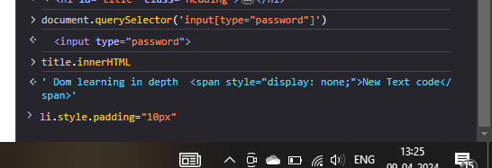

Nodelist in DOM:

Node list m agr kch modify krne hai to uske lie indexing type dene pdege for ex->

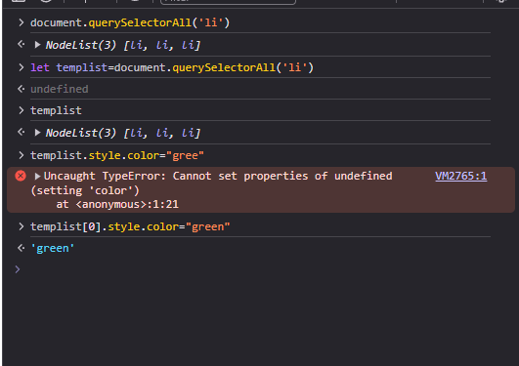

Nodelist—array jaise hai … bt array hai ni lekin kch method iske milte hai array

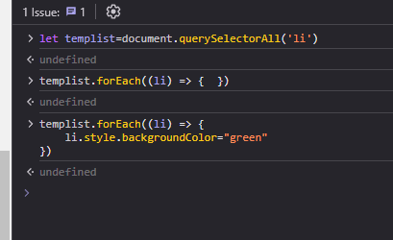

GetElementByClassName

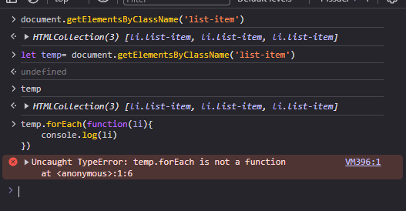

Conver temp list into Array.

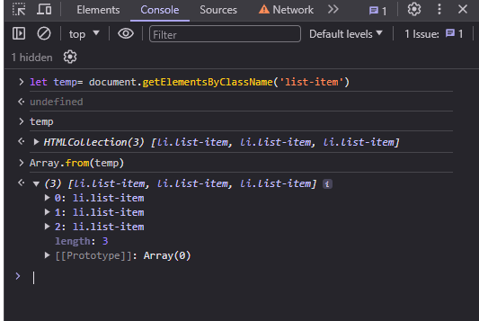

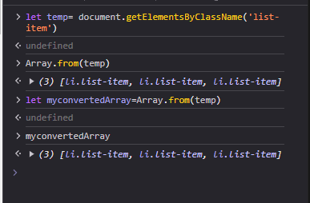

When we use querySelector or class so this is way to use values or change value.

Changes javascript webpage heading.

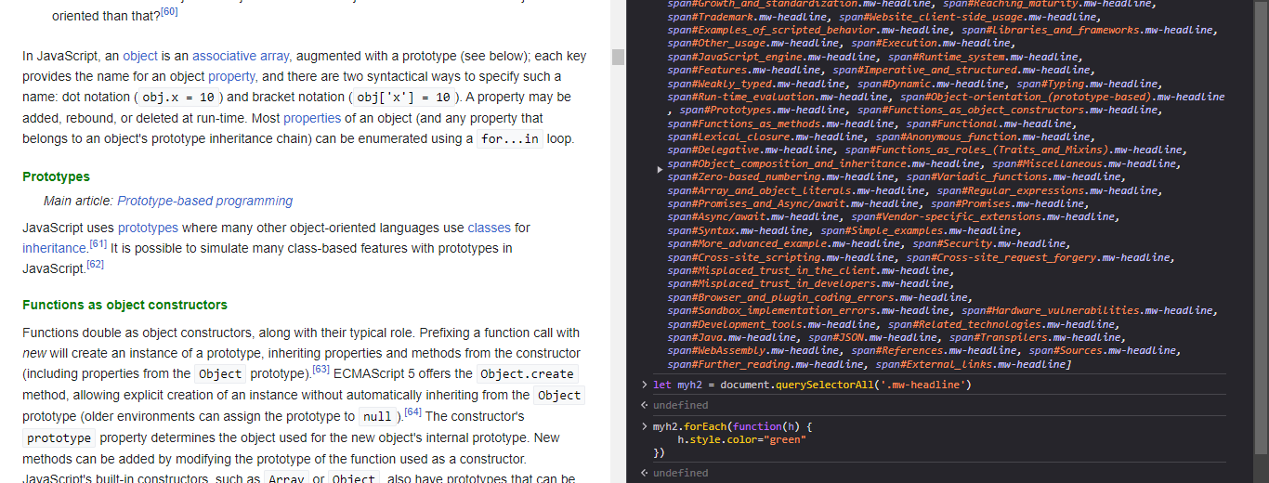

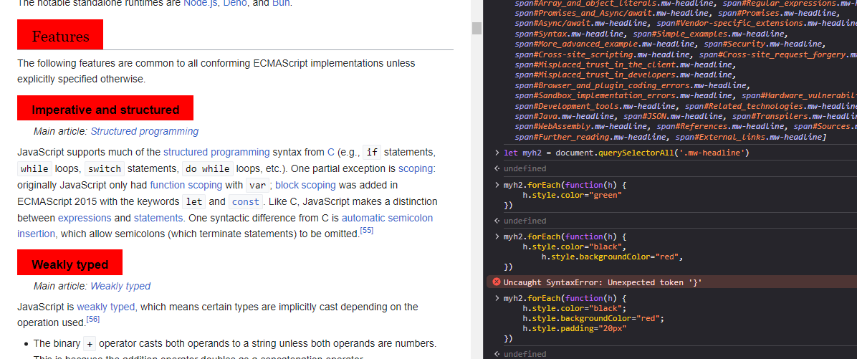

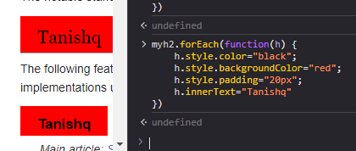

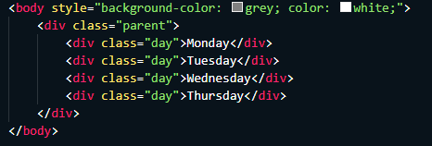

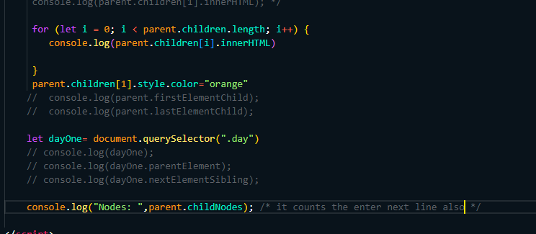

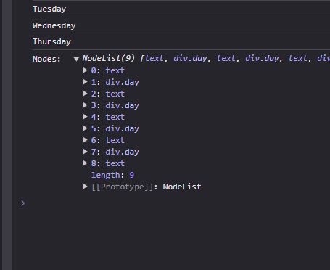

Here txt is for line break, jaise ki ek div over hone k bd jo hmlog enter kr rhe hai usi ko enter ko y text keh rhe hai